**Project: Woodson Park Academy & YMCA-ELC**

**Week Ending: May 8th, 2020**

**THIS WEEK:**

* Masonry and Brick continues at WPA
* MEP Overhead continues at WPA
* Framing continues at WPA
* GA Power onsite set transformer and started their work for permanent power
* Steel at YMCA continued
* Site Sub working on LL site utilities
* Fireproofing at 3rd floor of tower
* COA inspections – delays occurring due to COVID-19 action

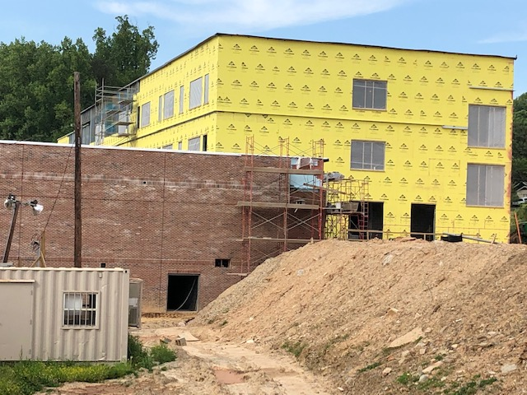 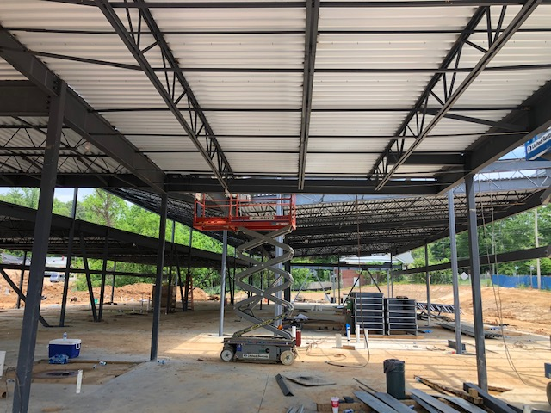

Sheathing south side of WPA Decking installed at YMCA

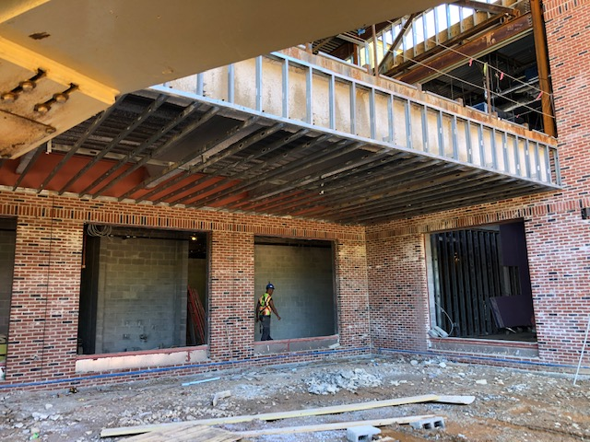 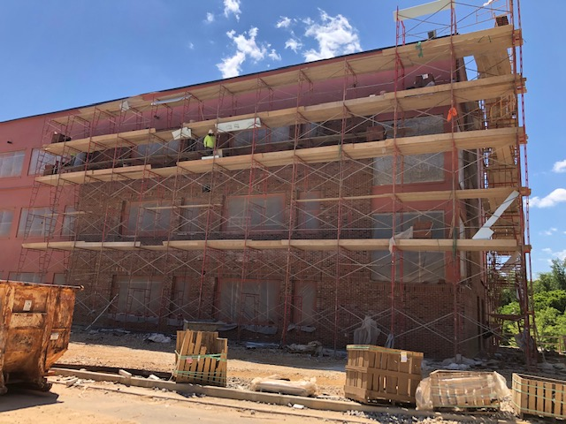

Framing courtyard area below Media Center Brick NE side of the WPA

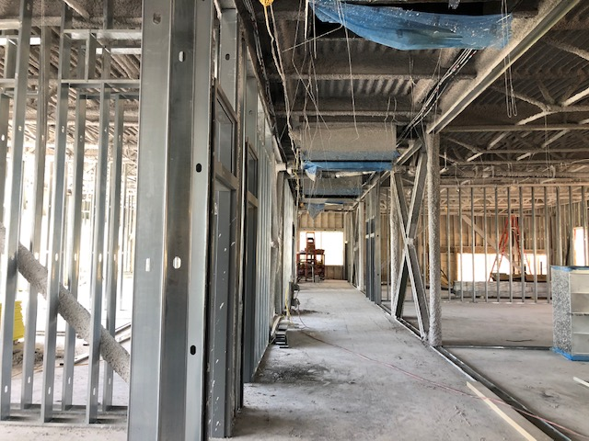 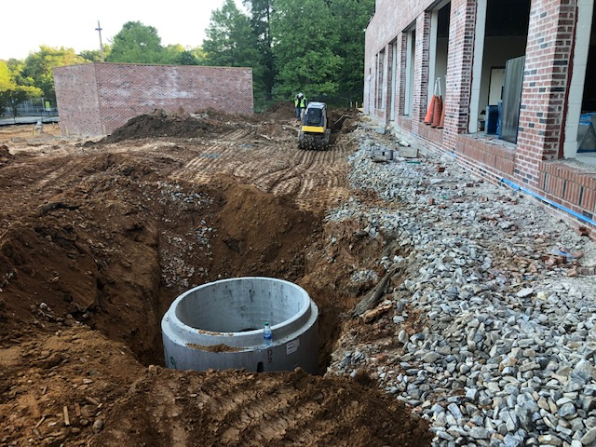

3rd Floor North framing and Fireproofing LL utilities continued at WPA

**NEXT WEEK – May 11th thru May 15th:**

* Masonry and Brick continues
* MEP Overhead continues
* Framing continues
* LL Utilities continue
* Structural Steel at YMCA continues
* Fireproofing at tower
* COA inspections – delays occurring due to COVID-19 action

**PAYMENT STATUS:**

* Gmp#1 $3,703,488.00
  + Paid to date amount $2,129,067.57
* GMP#2 $27,034,273.00
  + Paid to date amount $8,523,875.14
* GMP#3 $5,877,688.00
  + Paid to date amount $0.00
* GMP#4 $1,974,712.00
  + Paid to date amount $0.00

**WEATHER:**

* Total of 1/4” of rain for the week

**SCHEDULED DATE OF SUBSTANTIAL COMPLETION**

* WPA – November 4, 2020
* YMCA-ELC - November 12, 2020

**PREPARED BY:**

* **Matt Dauber, Carroll Daniel Construction Co.**